Practical 05

* **Installation of MongoDB**

Steps to install MongoDB:-

* + Go to link and Download MongoDB Community Server. We will install the 64-bit version for Windows.
  + Once the download is complete open the msi file. Click Next in the startup screen.

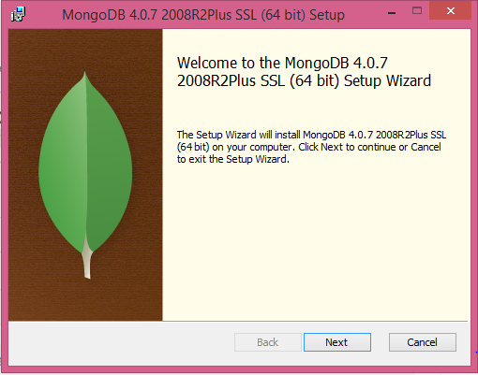

* + Accept the End-User License Agreement and Click Next.

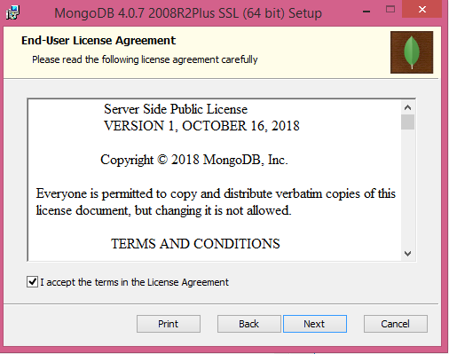

* + Click on the "complete" button to install all of the components. The custom option can be used to install selective components or if you want to change the location of the installation.

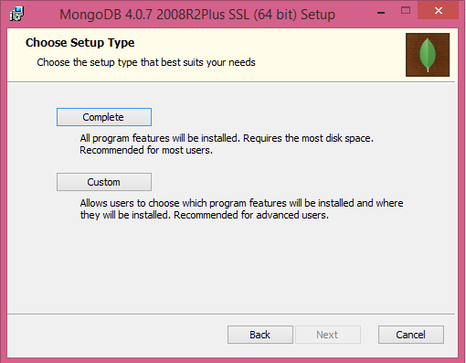

* + Select “Run service as Network Service user”. make a note of the data directory, we’ll need this later and Click Next.

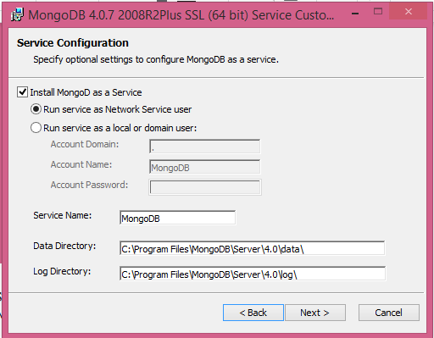

* + Click on the Install button to start the installation.

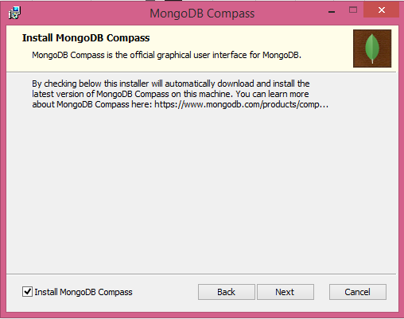

* + Installation begins. Click Next once completed.

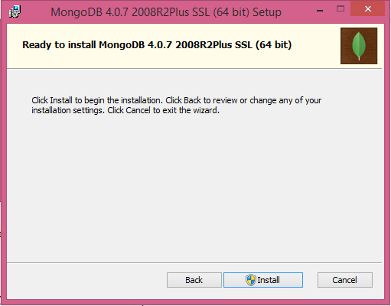

* + Click on Finish button to complete the installation.

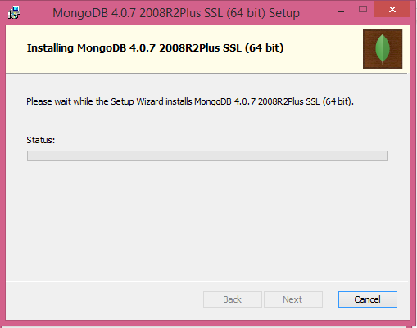

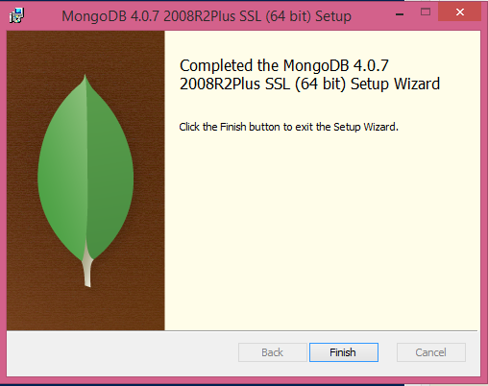

* + Checking the versions of ruby, python and pip installed.

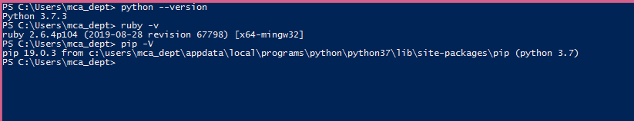

**MongoDB Basics**

Creation, Insertion, updation and deletion operations of MongoDB

Questions:

1. Create a database of your name

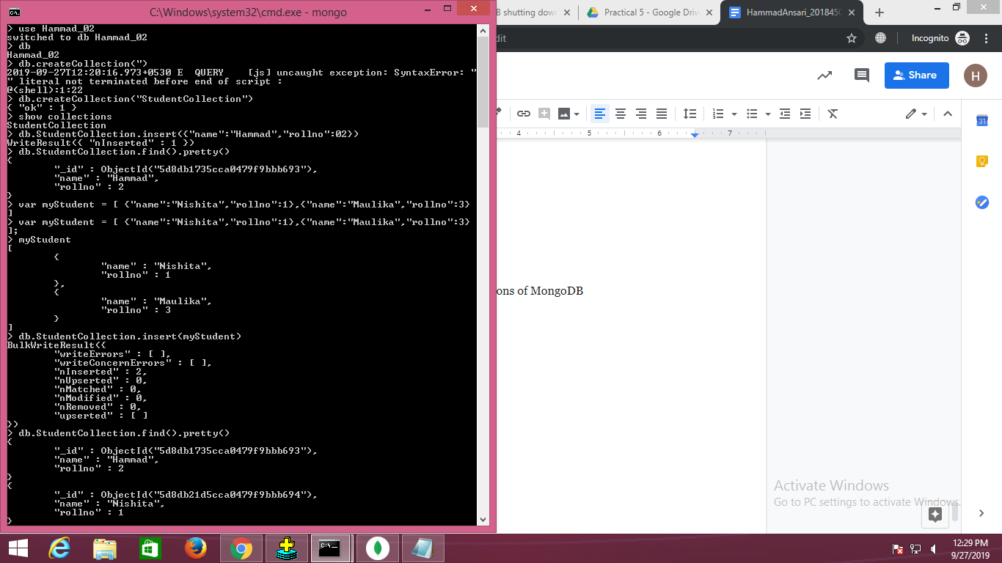

1. Create a collection



1. Create a document



1. Create documents using array

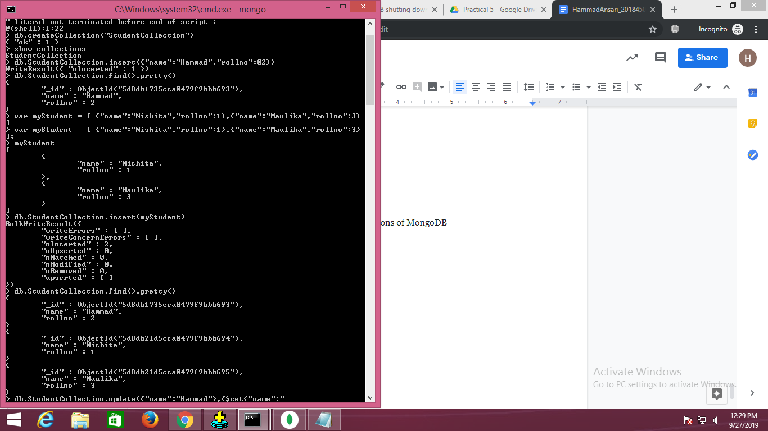

1. Updating a document

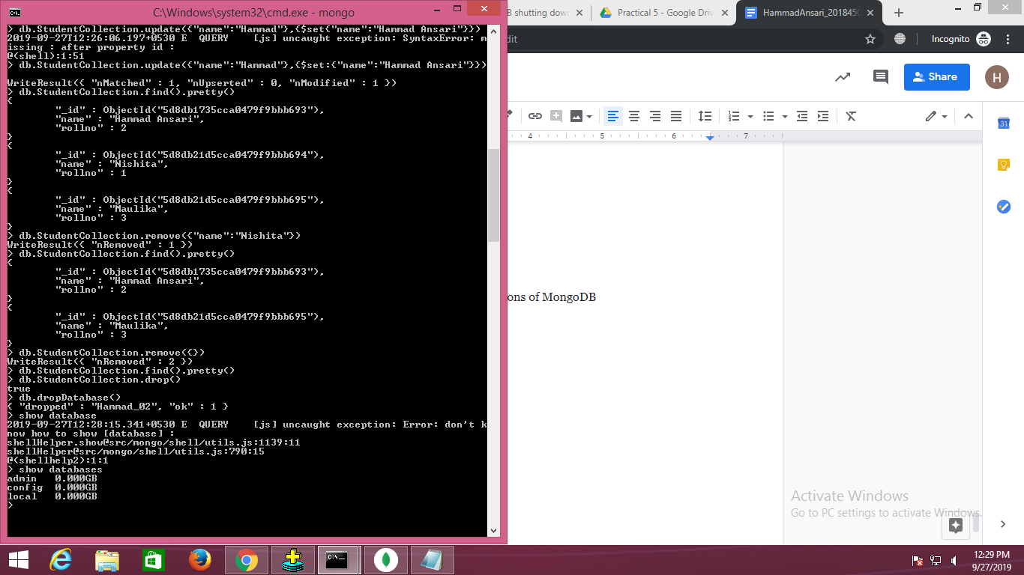

1. Deleting particular document



1. Deleting all document



1. Deleting a collection



1. Deleting a database



